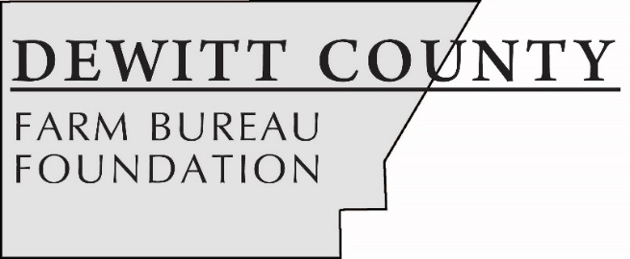

FOR IMMEDIATE RELEASE
March 19, 2020
Contact:
Allison Reinecke, DeWitt County Farm Bureau Manager
608-495-2116
dcfb3@frontier.com

Five students earn DeWitt County Farm Bureau Foundation scholarships
CLINTON, ILL. – Five area students have earned post-secondary scholarships from the DeWitt County Farm Bureau Foundation.
A panel of community judges selected Krayton Carter, Grace Arnold, Sarah Fabris, and John Koopman to receive scholarships as they enter their first year in college, and Riley Donelson to receive a scholarship to continue studying at Illinois State University.
Krayton Carter, a senior at Clinton High School, has earned the Ernest Thorp $1,500 scholarship. Carter, the son of Stacy and Belinda Carter, is planning to study Ag Production and Management at Lake Land College. He is involved in FFA, Clever Clovers 4-H Club, and Clinton High School Bass Fishing Team.
Grace Arnold, a senior at Clinton High School, has earned the DeWitt County Farm Bureau $1,000 scholarship. Arnold, daughter of Sam and Katy Arnold, is planning to enter the Ag-Transfer program at Lake Land College. She is involved in FFA, the Clever Clovers 4-H, and National Honors Society. She also raises and shows livestock.
Sarah Fabris, a senior at Clinton High School, has earned the I. Jackson & Imogene Blue $500 scholarship. Fabris is the daughter of Larry and Regina Fabris. She plans to study Agribusiness and Horticulture at Missouri State University. Fabris is active FFA, Clinton High School band, National Honor Society, and the Clinton Swim Team.
John Koopman, a senior at Monticello High School, has earned the $500 Tractor Drive scholarship. Koopman, the son of Joe and Eva Koopman, plans to attend Lake Land College within the John Deere Tech program. Koopman is active in FFA, 4-H, cross country, baseball, and pep club.
Riley Donelson, a junior at Illinois State University, has earned the $500 DeWitt County Farm Bureau College scholarship. Donelson, the daughter of Phil and Tanya Donelson, is studying Agriculture Communications and Leadership. She is active in the ISU Sigma Alpha Agriculture Sorority, ISU Agricultural Communications of Tomorrow, ISU Collegiate Farm Bureau, and the ISU Livestock Judging Team.
Donelson is also active in off-campus organizations including; Illinois Beef Association Intern, Illinois Pork Producers, and Clinton FFA Alumni.
The Foundation raises money throughout the year to provide scholarships and support agricultural education efforts in DeWitt County. Foundation sponsorships include Ag Day at the Museum for fourth grade students, the Illinois Agricultural Association Foundation scholarship program and FFA members’ participation in FFA-Farm Bureau BUILD Conference, a youth leadership development program.
The DeWitt County Farm Bureau Foundation’s largest fundraising effort, a golf outing, is scheduled for July 31, 2020, at the Woodlawn Country Club in Farmer City. A second fundraising event, the annual Tractor Drive, will be in September. Businesses or individuals interested in sponsoring the golf outing or tractor drive, or participating, may contact the DeWitt County Farm Bureau office at 217-935-2126.
-end-
CUTLINES
KraytonCarter: Krayton Carter, a senior at Clinton High School, has earned the $1,500 Ernest Thorp Family Scholarship. (Photo provided)
GraceArnold: Grace Arnold, a senior at Clinton High School, has earned the $1,000 DCFB Foundation Scholarship. (Photo by Woods Studio)
SarahFabris: Sarah Fabris, a senior at Clinton High School, has earned the I. Jackson & Imogene Blue $500 scholarship. (Photo provided)
JohnKoopman: John Koopman, a senior at Monticello High School, has earned the $500 Tractor Drive scholarship. (Photo provided)
RileyDonelson: Riley Donelson, a junior at Illinois State University, has earned the $500 DCFB College scholarship. (Photo provided)

