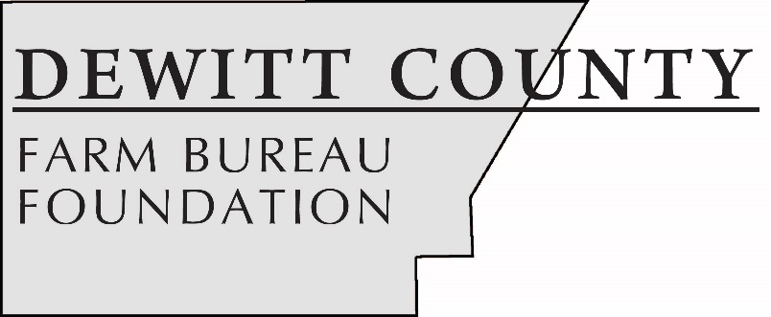

FOR IMMEDIATE RELEASE
March 26, 2019
Contact:
Janell Baum Thomas, DeWitt County Farm Bureau Manager
217-519-2892
dcfb3@frontier.com

Five students earn DeWitt County Farm Bureau Foundation scholarships
CLINTON, ILL. – Five area students have earned post-secondary scholarships from the DeWitt County Farm Bureau Foundation.
A panel of community judges selected Kinser Wargel, Anna Mills and Nick Becker to receive scholarships as they enter their first year in college, and Riley Donelson and Grace Clark to receive scholarships to continue studying at their respective colleges.
Kinser Wargel, a senior at Clinton High School, has earned the Ernest Thorp $1,500 scholarship. Wargel, the son of Thomas and Claudine Wargel, is planning to study Farm Management at the University of Illinois. He is involved in FFA, 4-H, Student Council, and is a youth leader with the Clinton United Methodist Church. Wargel is also part of the CHS Track and Field, Bass Fishing and Basketball teams, and is an Illinois State Scholar.
Nick Becker, a senior at Blue Ridge High School, has earned the $1,000 Foundation scholarship. Becker, the son of Don Becker and Angie Elliott, is planning to study Conservation/Forest Recreation and Park Management at Parkland College, with plans to transfer to Southern Illinois University. He is involved in FFA, National Honor Society, Student Council, Key Club, Big Brothers Big Sisters. Becker also plays on the BRHS baseball, soccer, and basketball teams.
Anna Mills, a senior at Clinton High School, has earned the I. Jackson & Imogene Blue $500 scholarship. Mills is the daughter of Daniel and Sharon Mills. She plans to study Pharmacy at Southern Illinois University – Edwardsville. Mills is active in 4-H, FFA, Scholastic Bowl, WYSE, and CHS Band. She was a member of the state-wining Envirothon team and is an Illinois State Scholar.
Grace Clark, a sophomore at Illinois Central College, has earned the $500 Foundation College scholarship. Clark is the daughter of Melissa Clark and the late Roger Clark. She is studying Agriculture Business and Communications at Illinois Central College, with plans to transfer to Illinois State University this fall. On campus, she is involved in the Ag Business Club and the ICC Livestock Judging Team. Off-campus, Clark is a member of the DeWitt-Macon-Piatt Prairie Beef Association, the Illinois and American Shorthorn associations, and is a Beef Quality Assurance (BQA) certified producer.

Riley Donelson, also a sophomore at Illinois Central College, has earned the $500 Tractor Drive scholarship. Donelson, the daughter of Phil and Tanya Donelson, is studying Agriculture Communications, with plans to transfer to Illinois State University in the fall. She is active in the Agribusiness Club and was a member of the ICC Livestock Judging Team. During her time at ICC, Donelson was on the Presidential Honors List (4.0 GPA) and Dean’s List. She will intern this summer at a local animal feed company.
“We’re excited for these students as they embark on their college experiences or continue their education,” said Foundation chairman Terry Ferguson. “All of our applicants this year showed exceptional leadership skills and agricultural involvement, and should be commended.”
The Foundation raises money throughout the year to provide scholarships and support agricultural education efforts in DeWitt County. Foundation sponsorships include Ag Day at the Museum for fourth grade students, the Illinois Agricultural Association Foundation scholarship program and FFA members’ participation in FFA-Farm Bureau BUILD Conference, a youth leadership development program.
The DeWitt County Farm Bureau Foundation’s largest fundraising effort, a golf outing, is scheduled for July 27, 2019, at the Clinton Country Club. A second fundraising event, the annual Tractor Drive, will be in September. Businesses or individuals interested in sponsoring the golf outing or tractor drive, or participating, may contact the DeWitt County Farm Bureau office at 217-935-2126.
-end-
CUTLINES
WargelKinser: Kinser Wargel, a senior at Clinton High School, has earned the $1,500 Ernest Thorp Family Scholarship. (Photo provided)
BeckerNick: Nick Becker, a senior at Blue Ridge High School, has earned the $1,000 DCFB Foundation Scholarship. (Photo provided)
MillsAnna: Anna Mills, a senior at Clinton High School, has earned the I. Jackson & Imogene Blue $500 scholarship. (Photo provided)
Clark-Grace: Grace Clark, a sophomore at Illinois Central College, has earned the $500 DCFB Foundation college scholarship. (Photo by Woods Studio)
Donelson-Riley: Riley Donelson, a sophomore at Illinois Central College, has earned the $500 Tractor Drive scholarship. (Photo by Woods Studio)

