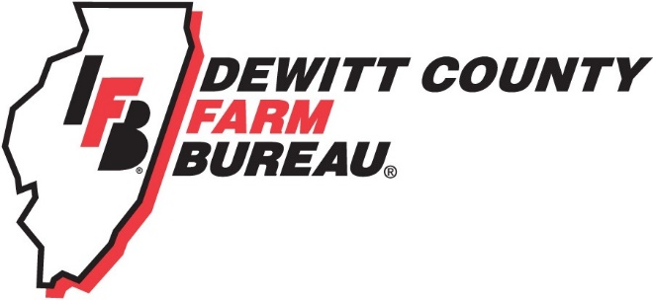

FOR IMMEDIATE RELEASE
February 17, 2020
Contact:
Allison Reinecke, DeWitt County Farm Bureau Manager
217-935-2126
dcfb3@frontier.com

First aid, body mechanics course highlights ag safety week

CLINTON, ILL. – DeWitt County Farm Bureau members and member families are invited to dinner and a seminar on first aid basics and injury avoidance through body mechanics course on March 5 in Clinton.
The featured speakers are Warner Hospital & Health Services specialists Deb Ertl, RN and Cheryl DeMent, PT.
The presenters will provide and demonstrate lessons on administering basic first aid, and ways to protect your body while lifting, carrying, and climbing.
Dinner, provided by a COUNTRY Financial Farm Safety Grant, is scheduled for 5:30 p.m. at the First National Bank & Trust Company building at 2 Kelli Ct., located across from Clinton High School.
RSVPs are requested via the DeWitt County Farm Bureau by March 2, by calling 217-935-2126 or emailing dcfb3@frontier.com
While the demonstrations will have a rural theme, lessons and techniques will also easily apply to the non-farming members in attendance.
“Many farmers and even non-farm people are inadvertently hurting themselves while performing basic tasks around the farm or house,” DeMent said. “Farmers, for example, are getting in and out of tractors, lifting heavy objects and climbing bins and other structures. We also see a lot of complaints coming from repetitive movements around planting and harvest times – sometimes caused by turning around or twisting. It’s important even for young people, young farmers, to recognize how to move correctly early on so we can prevent injuries.”
The first aid portion will include ways to care for minor abrasions, bumps or bruises, as well as appropriate responses to emergency situations.
The program takes place during National Ag Safety Week, March 1-7, 2020. The week brings awareness to health issues affecting the agriculture workforce, both mental and physical. More information on Ag Safety week can be found at www.Agrisafe.org.
Participants can expect the program to last just over two hours. DeWitt County Farm Bureau thanks COUNTRY Financial and Warner Hospital and Health Services for their assistance with this project.
For more information regarding the seminar, and to register, please call the DeWitt County Farm Bureau office at 217-935-2126, www.dewittcountyfarmbureau.com, or email dcfb3@frontier.com.
-end-

