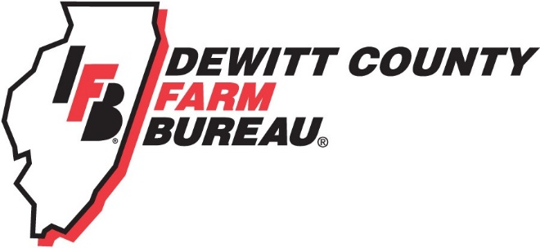

FOR IMMEDIATE RELEASE
February 6, 2019
Contact:
Janell Baum Thomas, DeWitt County Farm Bureau Manager
217-519-2892
dcfb3@frontier.com

First aid, body mechanics course highlights ag safety week
Ag safety week event aims to teach first aid, safe lifting to Farm Bureau members
- Farm Bureau partners with local businesses to bring awareness to ag safety week
- First aid kits, dinner offered to participants
- Farmers, rural families to learn first aid and body mechanics basics
CLINTON, ILL. – DeWitt County Farm Bureau members and member families are invited to dinner and a seminar on first aid basics and injury avoidance through body mechanics course on March 7 in Clinton.
The featured speakers are Warner Hospital & Health Services specialists Deb Ertl, RN; Erin Barger, EMT; and Cheryl DeMent, PT.
The presenters will provide and demonstrate lessons on administering basic first aid, and ways to protect your body while lifting, carrying, and climbing. The first 30 member households to register will receive a first aid kit courtesy of First National Bank & Trust of Clinton.
Dinner, provided by a COUNTRY Financial Farm Safety Grant, is scheduled for 5:30 p.m. The program will begin at 6 p.m. at the First National Bank & Trust Company building at 2 Kelli Ct., located across from Clinton High School.
RSVPs are requested via the DeWitt County Farm Bureau website or by phoning DCFB at 217-935-2126 no later than Friday, March 1. Registration is free for DCFB members.
While the demonstrations will have a rural theme, lessons and techniques will also easily apply to the non-farming members in attendance.
“Many farmers and even non-farm people are inadvertently hurting themselves while performing basic tasks around the farm or house,” DeMent said. “Farmers, for example, are getting in and out of tractors, lifting heavy objects and climbing bins and other structures. We also see a lot of complaints coming from repetitive movements around planting and harvest times – sometimes caused by turning around or twisting. It’s important even for young people, young farmers, to recognize how to move correctly early on so we can prevent injuries.”
The first aid portion will include ways to care for minor abrasions, bumps or bruises, as well as appropriate responses to emergency situations.
The program takes place during National Ag Safety Week, March 3-9, 2019. The week brings awareness to health issues affecting the agriculture workforce, both mental and physical.
The American Farm Bureau Federation is an industry partner on National Ag Safety Awareness week, as are County Farm Bureaus. More information on Ag Safety week can be found at www.Agrisafe.org.
“DeWitt County Farm Bureau is excited about this partnership to raise awareness of ag safety with our local businesses,” DCFB Manager Janell Baum Thomas said. “We, and our partners, recognize that ag producers are really susceptible to on- and off-farm injuries just because of the difficult nature of the job, and we think this is a program that will really benefit the community.”
Participants can expect the program to last just over two hours. DeWitt County Farm Bureau thanks COUNTRY Financial, First National Bank, and Warner Hospital and Health Services for their assistance with this project.
For more information regarding the seminar, and to register, please call the DeWitt County Farm Bureau office at 217-935-2126, www.dewittcountyfarmbureau.com/calendar, or email dcfb3@frontier.com.
-end-

