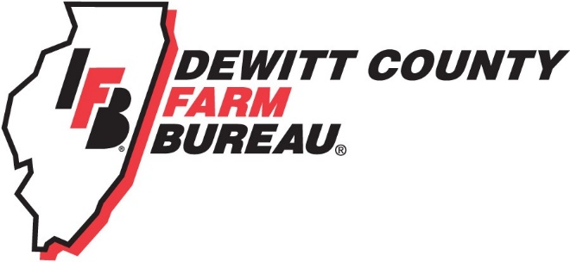

FOR IMMEDIATE RELEASE
June 4, 2020
Contact:
Allison Reinecke, DeWitt County Farm Bureau Manager
608-495-2116
dcfb3@frontier.com
Farm Bureau Young Leaders make local food bank donations
Farm Bureau Young Leaders donate to Salt Creek Resource Center and Clinton First Church of the Nazarene
Local food banks receive Farm Bureau donation
FARMER CITY, ILL. – The DeWitt County Farm Bureau Young Leaders are ensuring that local young farmers are doing their part to provide food and supplies for families impacted by the COVID-19 pandemic.
The DeWitt Farm Bureau Young Leader group has donated $600, split between the Clinton First Church of the Nazarene and Farmer City’s Salt Creek Parish Resource Center food banks to support those who may be struggling within local communities.
With business and schools being closed the past few months, food banks across the state have seen an increase in demand.
“Our young farmer group is happy to do what we can to bridge the food gap in the communities, especially during this crisis,” says Young Leader Chair, Tyler Barringer.
The group consists of Farm Bureau members ages 18-35 that have an interest in agriculture.
The Young Leaders group counts anti-hunger programs among its many roles in the county; others include agriculture promotion, leadership development, and agriculture education for both the community and youth.
For more information about Young Leaders and future food pantry collections, please call the DeWitt County Farm Bureau office at 217-935-2126 or email Farm Bureau manager Allison Reinecke at dcfb3@frontier.com.

-end-

