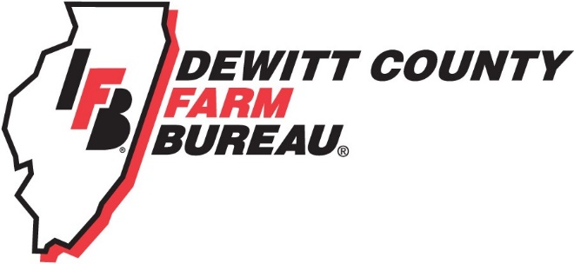

FOR IMMEDIATE RELEASE
November 16, 2018
Contact:
Janell Baum Thomas, DeWitt County Farm Bureau Manager
217-519-2892
dcfb3@frontier.com

Farm, business tax seminar planned for December 6
CLINTON, ILL. – Farm Bureau members are invited to learn more about tax changes under the Tax Cuts and Jobs Act during a Dec. 6 seminar at the DeWitt County Farm Bureau office in Clinton.
The seminar will begin at 8:30 a.m. Jason Shaw and Loni Trimble, Kemper CPA Group, LLP of Champaign, will present.
The seminar aims to cover the new qualified business income deduction, DPAD changes, estate tax issues, standard deduction increases, and tax rates. While the seminar does focus on farm businesses, small and construction businesses may also benefit from the information shared.
Presenters Shaw and Trimble have a combined 30+ years of tax and accountancy experiences. Shaw is a CPA and graduate of the University of Illinois who joined Kemper CPA Group in 2016. He has 15 years of experience assisting agriculture, manufacturing, construction and transportation clients.
Trimble, an enrolled agent (EA), is a Clinton native and graduate of McKendree College. Trimble joined Kemper CPA Group in 2018, and works with clients in varying industries, including agriculture, retail, real estate and construction.
Members are invited to attend this seminar. If you wish to attend, but do not have a Farm Bureau membership, please contact the office for more information about membership options.
For more information, please call the DeWitt County Farm Bureau office at 217-935-2126 or email dcfb3@frontier.com. RSVPs are not required, but are appreciated on the DeWitt County Farm Bureau’s Facebook Event, by email, or at www.dewittcountyfarmbureau.com/calendar.

-end-

