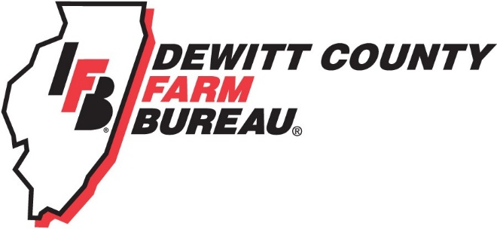

FOR IMMEDIATE RELEASE
August 1, 2018
Contact:
Janell Baum Thomas, DeWitt County Farm Bureau Manager
217-519-2892
dcfb3@frontier.com

DeWitt County Farm Bureau to Host 100-year Anniversary Celebration
- Event includes history display, appearance from IFB President Richard Guebert
- University of Illinois ACES Dean Kim Kidwell will speak
- Members encouraged to attend
CLINTON, ILL. – DeWitt County Farm Bureau will host its 100th Anniversary Celebration on Aug. 25, 2018, at the Little Galilee Christian Assembly Activity Center in rural Clinton.
The celebration will include a full display of DeWitt County and Illinois Farm Bureau (IFB) history, a porkchop dinner, appearance and remarks by IFB President Richard Guebert, and a keynote address by University of Illinois College of Agricultural, Consumer and Environmental Sciences Dean Kim Kidwell.
DeWitt County Farm Bureau was formed in 1918 to support the County’s farmers in obtaining inputs, learning new farming techniques, finding and hiring farm workers, building roads and infrastructure, and mitigating animal and plant diseases and pests. Later, the Farm Bureau also would assist farmers by insuring automobiles, homes and equipment, under what would later become COUNTRY Financial.
Tickets for the event are $10 for adults and $5 for children. They will be available until Aug. 21.
To sign up, members may visit www.DeWittCountyFarmBureau.com to download and mail an order form, ILFB.org > Member Center to pay online, or stop by the office at 1060 State Highway 54, Clinton.
As part of the celebration, DCFB also is making available commemorative “Established 1918” gate signs for $25.
For more information, please call the DeWitt County Farm Bureau office at 217-935-2126 or email dcfb3@frontier.com.
-end-

Then: DeWitt County Farm Bureau members, 1920s.
Then: DeWitt County Farm Bureau Directors, 1950.
Now: DeWitt County Farm Bureau Directors, 2017.

